CASE STUDY: AUTOMOBILE MANUFACTURING USING SENSOR TECHNOLOGY

Introduction
The automobile industry is rapidly evolving toward Industry 4.0, where sensors, data analytics, and automation form the backbone of smart manufacturing. Modern vehicle production involves extensive use of sensors not only in the vehicles themselves but also in the manufacturing process, ensuring higher precision, safety, and efficiency.
This case study focuses on Toyota Motor Corporation as a representative example of how sensor technology enhances automobile manufacturing.

Company Overview
Toyota Motor Corporation is one of the world’s largest automobile manufacturers, producing over 10 million vehicles annually. The company integrates advanced technologies like IoT, robotics, and AI in its manufacturing plants across Japan, the U.S., and Europe.
Problem Statement
Before the integration of smart sensors, Toyota’s production lines faced several challenges:
- Unplanned Downtime: Machine failures often occurred without warning, leading to delays.
- Quality Variability: Manual inspection could miss defects.
- Energy Inefficiency: Lack of real-time monitoring led to excessive energy use.
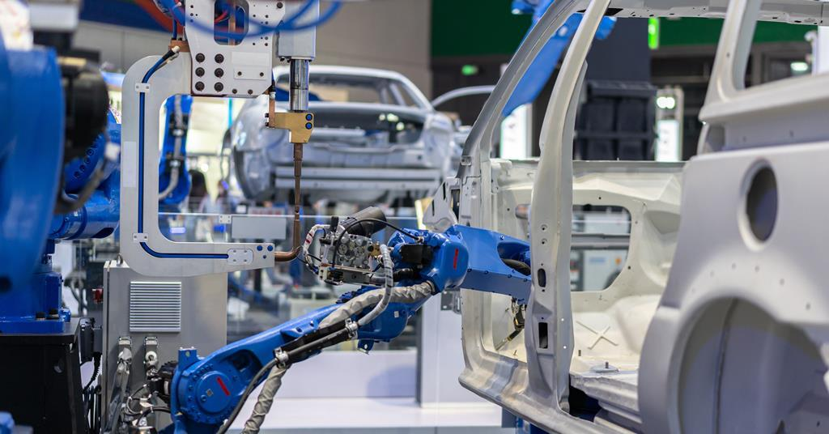
- Safety Risks: Workers were exposed to potential hazards during assembly

Implementation of Sensor Technology
Sensor Type | Function | Application in Manufacturing
Proximity Sensors | Detect object presence/position | Robotic arm alignment, part placement
Temperature Sensors | Monitor heat levels | Engine block casting, paint shop ovens
Vibration Sensors | Detect abnormal machine vibration | Predictive maintenance
Pressure Sensors | Measure hydraulic/pneumatic pressure | Welding and stamping processes
Optical/Camera Sensors | Visual inspection | Paint quality, assembly verification
Force/Torque Sensors | Measure applied force | Robot-assisted tightening, assembly
IoT-enabled Sensors | Data collection and transmission | Real-time production monitoring

Implementation Process
- Assessment Phase: Identify critical points in the production line where sensor monitoring could reduce downtime and defects.
- Sensor Integration: Install sensors on robots, conveyor belts, welding stations, and engine assembly lines.
- Data Collection & Networking: Connect sensors via an Industrial IoT (IIoT) network for real-time data transmission.
- Analytics & AI: Use machine learning algorithms to analyze sensor data for anomaly detection and predictive maintenance.
- Human-Machine Interface (HMI): Deploy dashboards for supervisors to monitor production performance and alerts.

Outcomes
Metric | Before Sensors | After Sensors | Improvement
Machine Downtime | 12 hrs/month | 2 hrs/month | ↓ 83%
Product Defect Rate | 2.5% | 0.7% | ↓ 72%
Energy Consumption | 100% baseline | 85% | ↓ 15%
Worker Safety Incidents | 8 per year | 2 per year | ↓ 75%

Benefits
- Predictive Maintenance: Early fault detection reduced unplanned downtime significantly.
- Enhanced Quality Control: Vision sensors detected defects in real-time.
- Operational Efficiency: Automated monitoring optimized line speed and minimized waste.
- Safety: Sensor-equipped robots reduced human exposure to hazardous environments.
- Data-Driven Decisions: Production managers used live dashboards to optimize workflows.

Challenges
- High Initial Cost: Installing and calibrating sensors required substantial investment.
- Data Overload: Managing large volumes of sensor data needed robust analytics systems.
- Cybersecurity: Networked sensors increased exposure to potential cyber threats.

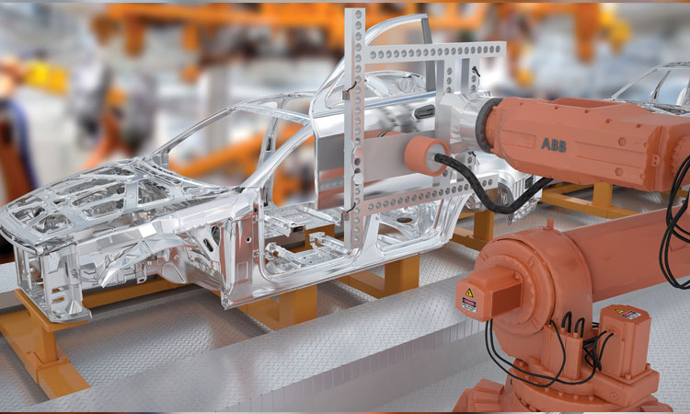

Future Prospects
Toyota plans to integrate 5G connectivity and edge computing to further reduce latency in sensor data processing. AI-driven digital twins will simulate and optimize factory operations before physical implementation.

Conclusion

Sensor technology has transformed automobile manufacturing by making it smarter, safer, and more efficient. Toyota’s experience demonstrates that integrating sensors with IoT and AI not only reduces costs but also drives sustainable production practices.

CASE STUDY: HEALTHCARE SYSTEM USING SENSOR
TECHNOLOGY

INTRODUCTION
The healthcare industry is undergoing a technological transformation driven by smart sensors and Internet of Things (IoT) technologies. These innovations enable real-time patient monitoring, predictive diagnostics, and remote healthcare, making treatment more accurate and accessible.
This case study focuses on Apollo Hospitals (India) as an example of how healthcare organizations use sensor technology to improve patient outcomes and operational efficiency.

ORGANIZATION OVERVIEW
Apollo Hospitals, one of Asia’s largest healthcare providers, operates over 70 hospitals with a strong focus on digital health innovation. In recent years, Apollo has integrated wearable sensors, smart medical devices, and IoT platforms to create a Smart Health Monitoring System (SHMS).

PROBLEM STATEMENT
Before adopting sensor-based monitoring, Apollo Hospitals faced challenges common in healthcare systems:
- Delayed Emergency Response: Lack of real-time patient data led to delayed interventions.
- Overburdened Staff: Manual vitals monitoring increased workload and human error.
- Limited Remote Care: Chronic patients had to visit hospitals frequently for routine check-ups.
- Data Fragmentation: Patient data from different departments were not integrated for analysis.

IMPLEMENTATION OF SENSOR TECHNOLOGY

Sensor Type | Function | Application
Heart Rate Sensor (ECG/EKG) | Measures electrical activity of the heart | Continuous cardiac monitoring
SpO₂ Sensor | Measures oxygen saturation | Used in COVID-19 wards and ICUs
Temperature Sensor | Tracks body temperature | Detects fever, infection monitoring
Blood Pressure Sensor | Monitors systolic/diastolic pressure | Remote hypertension monitoring
Glucose Sensor | Measures blood sugar levels | Diabetes management
Motion/Accelerometer Sensor | Detects patient movement | Fall detection, activity tracking
Respiratory Sensor | Measures breathing rate | Used in respiratory and sleep disorder monitoring

IMPLEMENTATION PROCESS
- Assessment & Design: Identify critical care areas and chronic conditions needing real-time monitoring.
- Sensor Deployment: Equip patients with wearable sensors (smartwatches, patches, or implantables).
- Data Integration: Sensors transmit data via Bluetooth/Wi-Fi to Apollo’s IoT Health Cloud.
- Data Analysis: AI algorithms analyze real-time data for abnormalities (e.g., arrhythmia, hypoxia).
- Alerts & Response: Automatic alerts sent to doctors, nurses, and emergency teams if anomalies are detected.
- Patient Portal: Patients access their health reports via mobile apps for self-monitoring.

OUTCOMES
Metric | Before Sensor Use | After Sensor Use | Improvement
Emergency Response Time | 15 minutes | 5 minutes | ↓ 67%
Readmission Rate (Chronic Patients) | 25% | 12% | ↓ 52%
Manual Monitoring Errors | 8% | 2% | ↓ 75%
Patient Satisfaction Score | 78% | 92% | ↑ 14%

BENEFITS
- Continuous Patient Monitoring: Real-time vitals reduce the risk of unnoticed deterioration.
- Predictive Healthcare: Early detection of cardiac or respiratory distress via AI models.
- Remote Patient Management: Enabled telemedicine for rural and elderly patients.
- Data-Driven Decision Making: Centralized dashboards improved clinical decision support.
- Operational Efficiency: Reduced nurse workload and optimized hospital resource allocation.

CHALLENGES
- Data Privacy Concerns: Sensitive health data requires strong encryption and HIPAA compliance.
- System Integration: Difficulty integrating data from multiple sensor manufacturers.
- Cost of Deployment: Initial investment in IoT infrastructure and training.
- Battery & Device Reliability: Sensor devices need regular calibration and power management.

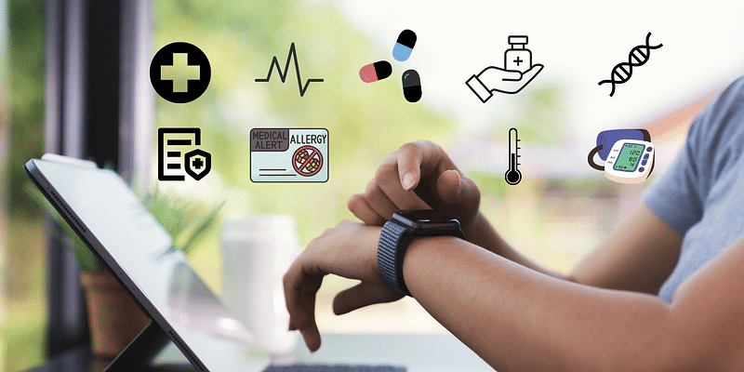

FUTURE PROSPECTS
Apollo Hospitals aims to expand its smart healthcare network using:
- AI-driven predictive analytics for early disease detection.
- 5G-enabled telehealth systems for faster, real-time monitoring.
- Nanotechnology-based biosensors for minimally invasive diagnostics.
- Digital Twins of Patients, simulating body functions for personalized medicine.

CONCLUSION
Sensor technology has revolutionized healthcare delivery by making it proactive, predictive, and personalized. Apollo Hospitals’ successful implementation shows how IoT and sensors improve patient outcomes, reduce costs, and enable continuous care beyond hospital walls.

